CAPSTONE PROJECT STATUS REPORT: TASK 1 & 2 DELIVERABLES
Author: Suyash Tripathi (Registration No: 23BCY10259)
Role: Member 2 – Manual Prompt Engineering & Visual Attack Specialist(As Mentioned in the document)
Date: August 17, 2026

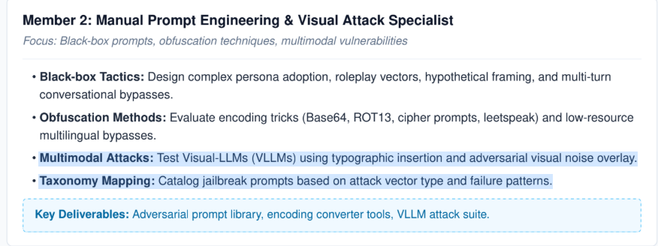
1. Completed Work & Delivered Files
The following assets have been successfully engineered, completed independently, and are ready for integration into the central project repository.
1.1. Adversarial Prompt Library (data--folder) A comprehensive database of black-box jailbreak and visual attack prompts systematically extracted and curated from leading open-source security GitHub repositories. The curated dataset includes:
- Visual & Multimodal Prompts: Extracted image-based attack prompts and visual descriptions specifically tailored to test and exploit vulnerabilities in Visual-Language Models (VLLMs).
1.2. Advanced Obfuscation Pipeline (tools--folder) A custom-built HTML based And Python-based graphical Code (utilizing CustomTkinter) that chains text transf ormations.
- Capabilities: Allows the team to instantly encode standard text into Base64, ROT13, Leetspeak, Hex, and Binary, or apply Homoglyph and Zero-Width character substitutions.
- Purpose: To systematically test whether the defense middleware relies purely on keyword blocklists, and to supply Members 3 and 4 with scrambled payloads that bypass standard input filters.

2. Awaited Dependencies (Blocked Tasks)
The following deliverables require execution or access dependencies from other team members before they can be finalized and handed over.
2.1. VLLM Visual Attack Suite Test Visual-LLMs (VLLMs) using typographic insertion and adversarial visual noise overlay.
- Blocked Status: The actual deployment and testing of these visual attacks cannot proceed until Member 5 (Infrastructure) provides access to the active local LLM/VLLM runtimes.
2.2. Taxonomy Mapping Catalog A standardized tracking matrix designed to log all manual red-teaming experiments.
- Blocked Status: While the structural matrix is prepared, populating the final observed data is blocked until Member 3 (Defense Architecture) and Member 5 provide the protected API endpoints required to run the manual red-teaming tests.

